KNIGHTON TOWN COUNCIL

Minutes of Full Council Meeting of Knighton Town Council held at the Civic Centre on Wednesday 19th October 2022 at 7:00 pm.

3 members of the public in attendance.

Rob Edwards was still very concerned to the fact there has been delay after delay on repairing the damaged wall in Station Road and impressed on Powys Councilor C Kenyon Wade confirmed that she was meeting Steven smith tomorrow from Powys CC highways and would give an update
There were also concerns if relation to the viability of a fire station in Knighton. Rob Edwards confirmed that a meeting had been organised with the deputy Chief fire officer Craig Fannerly 0n Tuesday 8th November by the flood group and Knighton town council would attend also.
Rob Edwards suggested that a map be used as signage for the positioning of defibrillators in Knighton and a requirement for members and other interested parties to be trained on usage. Clerk to contact Brian Jones to source training.
1 Members Present.

Cllr B Andrews Cllr C Branford
Cllr M Coxill Cllr C Bevan
Cllr M Vaughan Cllr H Adams- Evans
Cllr T Taylor Cllr D Williams
Cllr S Vaughan

County Councillors Kenyon Wade

To receive apologies.

County Councillor A Williams

Cllr P Ford Cllr B Butler
Cllr T Sharp and Cllr B Caine
Cllr J Goodband resigned
as a Councillor

2 Declarations of Interest

None.

3 To receive and approve the minutes of the following meetings:

Full Council 26th September 2022
It was proposed by Cllr H Adams Evans Branford and seconded by Cllr D Williams that the minutes are an accurate and true record. Members all in favour

4 Matters arising from the minutes:

a) To receive the Clerk’s oral progress report.

Steering group update with Knighton Community Centre-youth and family provision in the town
Cllr B Andrews confirmed that no meeting has been called by the Chair, however the youth group would be willing to work with the Council on making better use of the former tennis court site.

Improving Bus services in Knighton.
Residents of Knighton to be surveyed on the proposal of having a bus stop/shelter as soon as possible on brookside square.
Civic Centre Charitable Trust
Clerk and Deputy Mayor have met Nick Venti and are now able to apply for Community Interest Company to run the Civic Centre.

Update on grant applications

Cllr H Adams Evans confirmed that no further applications have been submitted.

Training plan

Training plan agreed as attached

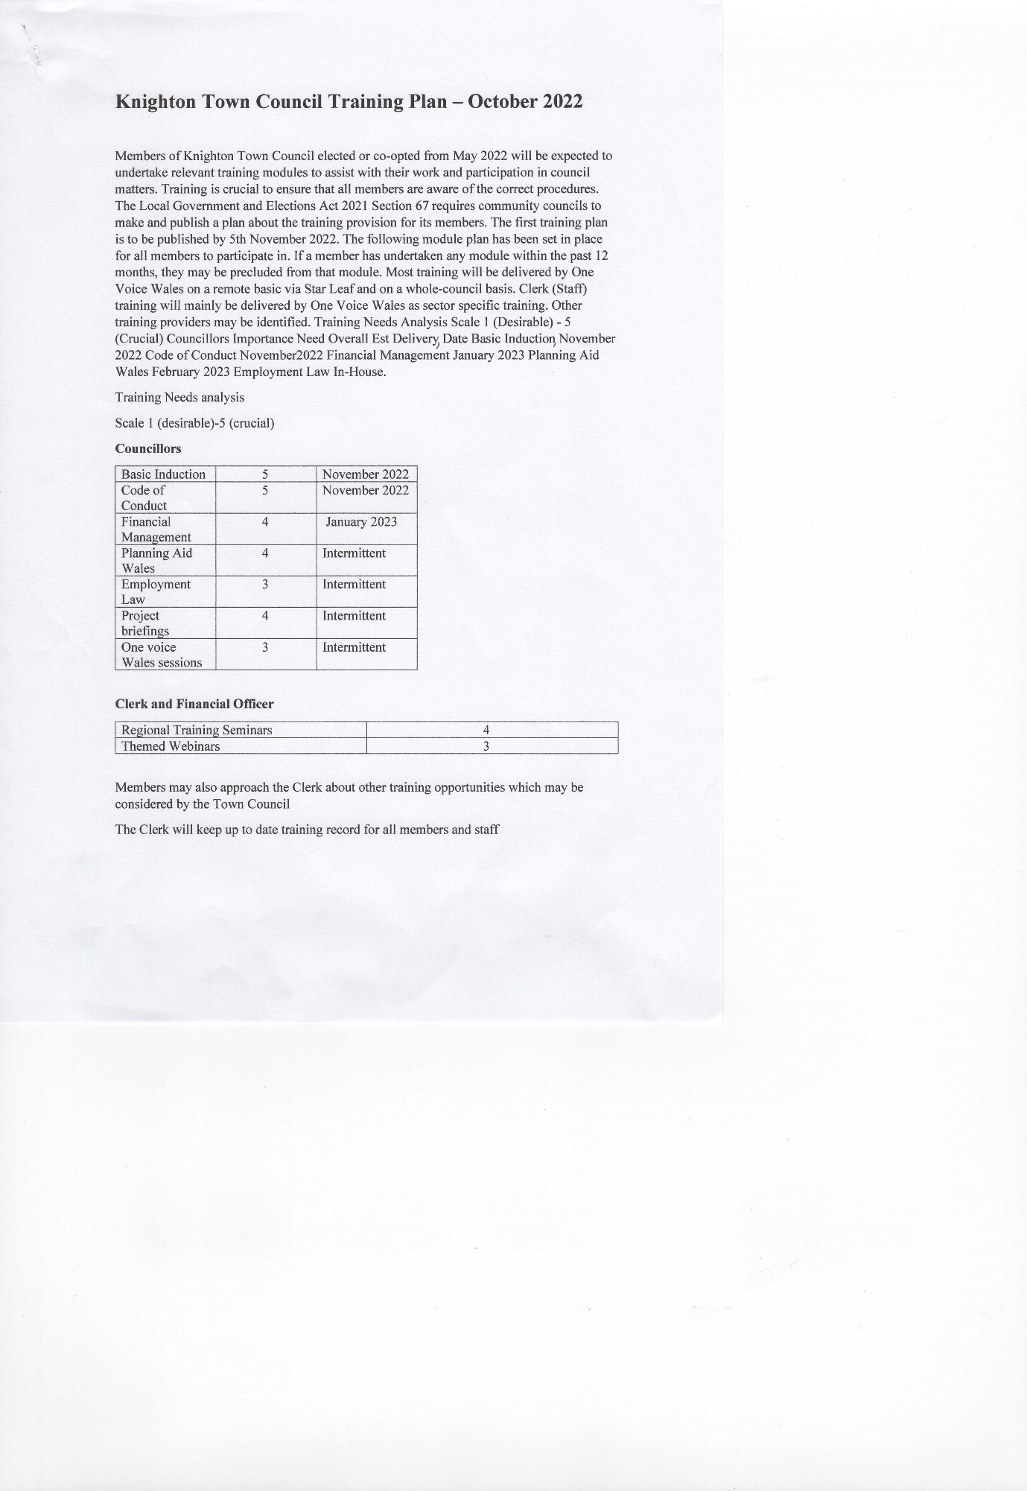

Results of Town survey

Richard Gabb gave the attached presentation which was warmly accepted by Councilors s and accepted as a way forward for funding streams

See attached report

Local development Plan-call for candidate sites
Members to consider sites in Knighton for new starter homes and small industrial units

b) To receive any other relevant information from members.
Switching on Christmas lights
Agreed date 3rd December 2022
Putting up the lights Sunday 20th November

Remembrance Sunday
Sunday 13th November-Clerk to send invitations and order extra wreath to be placed on war graves in old cemetery
Volunteer of the year
Nominees-Sally Saginoz and Pete Lewis
Sally received most votes
Appointment of replacement Clerk
Agreed to have full Council meeting
Knighton Food Bank
It was proposed by Cllr D Williams and seconded by Cllr B Andrews not to charge food bank for use of 2 rooms. Members all in favour except 1 abstention
Reviewing and updating Council policies
It was agreed that the Clerk update Council policies and list date reviewed
5 County Councillors Reports

Report from County Councillor A Williams-No report

Report from County Councillor C Kenyon Wade-. As above.

6 Notice of Motion

Cllr J Goodband-Substandard living conditions in some Knighton properties
Fallen
Cllr J Goodband-Are Knighton Town Council able to help Bradfords in improving the shop signage.
Fallen
Cllr M Vaughan-Need for bus shelter on Presteigne Road
Clerk to write to Powys

7 Mayor’s communications.

Mayor’s engagements.
Friday 14th Comm AGM.
Saturday 15th KDRSG - Space4u Cardiff day trip.

Announcements

From Nov 1st Brendan Rogers ceasing to continue with Dog Poo Bags.

Invitation to Knighton Festival private viewing of artwork on display.

T TH
8 To approve the monthly accounts for September and to receive and approve monthly invoice payments for October.
It was proposed by Cllr B Andrews and seconded by Cllr C Branford that the accounts are an accurate and true record
Members all in favour
Recycling fund balance of 20K made up of
10k grant for Bowling green lane tennis courts
5.6k grant for 3 toilet blocks
4.4k recycling income from Powys CC

9 Planning.

Town and Country Planning Act 1990

Application Reference: 22/1616/FUL
Grid Reference: E:331432 N: 270839
Proposal: Creation of 3 ponds on a section
of marshy field
Site Address: Upper Pitts, Pitts Lane,
It was proposed by D Williams and seconded by S Vaughan to recommend approval of this application

10 Correspondence

None

11 Financial Assistance
None.

12 Urgent Items
Members given code numbers for key lock and defib case by mayor

Meeting closed at 9:35pm

.

