Town Clerk: Ms Lisa James

Knighton Town Council
The Civic Centre
West Street
KNIGHTON
Powys
LD7 1EN

19 October 2023

Dear Councillor

You are hereby summoned to attend a Full Council Meeting of Knighton Town Council in the Civic Centre, Knighton on Wednesday 25 October 2023 at 7:00 pm for the purpose of transacting the business listed in the attached agenda. Papers will be circulated in advance.

Declaration of Interest Forms will be available at the start of the meeting. Members are requested to declare any personal and/or prejudicial interests they may have in matters to be considered at this meeting.

Yours sincerely
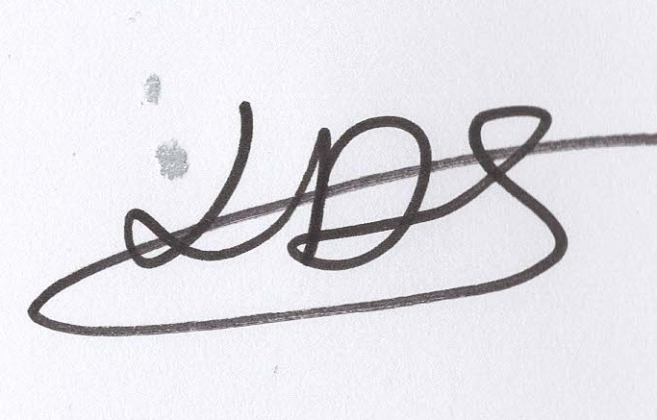
Ms L James

Town Clerk

Tel: 01547 529660
Email: knightontowncouncil@outlook.com

FULL COUNCIL MEETING
7.00PM ON WEDNESDAY 25 OCTOBER 2023
AT THE CIVIC CENTRE, WEST ST., KNIGHTON, POWYS LD7 1EN
https://zoom.us/meeting/82310022173

The first ten minutes will be allowed to receive issues from members of the public; these may be considered at a later meeting.

AGENDA
- Apologies.
- Declarations of Interest.
- Approve minutes of last meeting.
- Matters arising from minutes of last meeting.
- Approve September accounts.
- Clerk’s Report.
- Mayor’s Report.
- County Councillor Reports.
- Correspondence.
  - Slow Ways national walking network, request KTC involvement in checking routes.
  - Thank you letter from resident re tree felling.
- Financial Assistance.
  - Knighton Show and Carnival Committee: request for £200.00 donation to the 2023 Bonfire Night celebrations.
- Planning.
None received at time of drafting agenda.
- Upcoming Events
  - To finalise plans for Remembrance Sunday Event 2023.
  - To finalise plans for Christmas Lights and Event 2023.
- Governance
  - Approve KTC Financial Regulations.
  - Discuss and approve terms of reference for the Personnel Committee.
- To appoint 2 Councillors to the Personnel Committee to replace former Cllr. P Barrett and Cllr. B Caine.
- Urgent Items.

